Emergency Telecommunicators Need
Access to a Community AED Registry

Public Safety Answering Point (PSAP) telecommunicators are a critical link in the cardiac arrest chain of survival. Placing the proper tools in their hands can improve outcomes.

“911. What’s your emergency?”

"My friend just collapsed. We’re at the CVS on Main Street.”
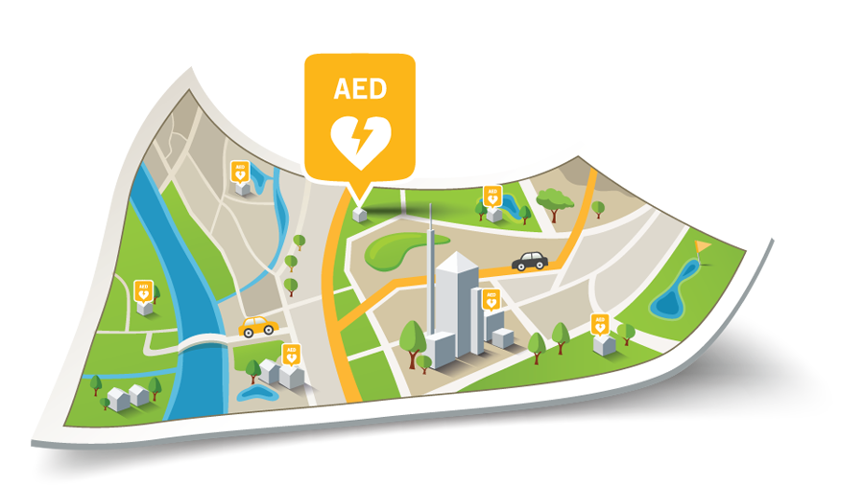
“Is your friend conscious?”

“No. I can’t wake her.”

“Is she breathing normally?”

“No.”

“Is there an AED nearby?”

“I don’t know.”

The PulsePoint Foundation provides technology to make "Is there an AED nearby?" an unnecessary question during cardiac arrest call processing while also advocating for broad adoption of this lifesaving capability. Our goal is for the telecommunicator to instead inform the caller of the location of nearby AEDs. Consider how much more effective it would be to say, “there is an AED at that store,” and direct the caller to “send someone to retrieve the AED from the customer service counter,” as CPR instructions begin. We back our advocacy and commitment with comprehensive and accessible resources. By providing exceptional, industry-supported AED registry solutions at no cost—and we genuinely mean free in all aspects—we strive to remove deployment impediments. Our Foundation offers dedicated AED registry support, training, interfaces, and outreach materials at no cost as well. PulsePoint is a public, non-profit organization providing hosted AED registry solutions to emergency communications centers as a core part of its mission to improve cardiac arrest survival.

The PulsePoint AED registry integrates seamlessly with Priority Dispatch’s ProQA Paramount allowing dispatchers to inform callers of the exact location of nearby AEDs directly within the protocol and with no changes to workflow. Paramount is one of the easiest ways to provide dispatchers access to the registry. As a FirstNet Certified application, PulsePoint AED can be deployed in your center with confidence. FirstNet Certified solutions must demonstrate 99.99% availability and pass independent 3rd party security, data privacy, and performance audits.

If you don’t yet have an AED registry in place, you can start addressing that void today. Download the free PulsePoint AED app and enter your first AED. Watch this brief video to see just how easy it is. Once your organization is ready to begin in earnest, reach out to us for agency credentials and basic training. We’ll get you an orientation to the hosted registry and produce custom outreach materials for your use. You can use these marketing tools and collateral to inform and engage your community and make sure every AED in your jurisdiction is added to the registry. Direct citizen participation can help create greater location awareness and mindfulness of the vital role AEDs play in out-of-hospital cardiac arrest survival. If you’re still using spreadsheets, hard-to-maintain premise data, or data that can’t be integrated into dispatch workflows, we can help move your current records to a next-generation platform.

When a caller contacts your center and reports a likely cardiac arrest, getting CPR started and sourcing a nearby AED are critical actions to initiate without delay. The capability to provide both Telecommunicator CPR (T-CPR) and nearby AED locations is readily available today. Let the team at PulsePoint show you how to build an AED Registry for emergency use. It’s a simple process that starts paying lifesaving dividends almost immediately. Your dispatch center staff will appreciate the effort, as will your community. Please don’t hesitate to get in touch.

